# Project Design Phase-I Solution Architecture

|  |  |
| --- | --- |
| Team ID | PNT2022TMID10050 |
| Project Name | Personal Assistance for senior citizens who are self-reliant |
| Maximum Marks | 4 Marks |

**Solution Architecture:**

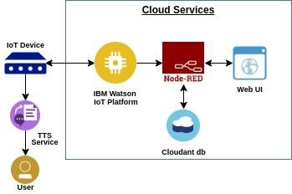

# IOT Device:

* Getting the information from the application about the time and name of the medicines.
* Sending an SMS to the persons.
* Gathering the user information from the web application in which the user registers.
* To accomplish this, we have to complete all the activities listed below:

# Create and Configure IBM Cloud Services:

* Create IBM Watson IOT platform
* Create a device & configure the IBM IOT Platform
* Create Node-Red service
* Create a database in IBM Cloudant DB to medicine names and time.

# Develop a web application using Node-RED service:

* Develop the web application using Node-RED.
* Develop a python script to publish the medicine names and time to remind details to the IBM IOT Platform.

# Develop an application:

* Develop an application in which the user can feed the data on the medicine name and time.
* Develop an application which can transmit the signal on the reminder of the medicines at the time specified.